**Experiment – 7: Data Visualization Using Tableau (**

**AIM:**  
To visualize and analyze IPL player performance and team statistics using Tableau by creating interactive dashboards consisting of various charts and graphs.

**Dataset Used:**  
**IPL Dataset** (Columns may include: Player, Country, Team, Age, Captaincy Experience, Playing Role, Matches, Innings, Runs, Batting Average, Strike Rate, Fours, Sixes, Wickets, Bowling Average, Economy Rate, and Sold Price, etc.)

**PROCEDURE:**

### **1) Importing Dataset into Tableau**

**Steps:**

1. Open **Tableau Desktop** or **Tableau Public**.
2. On the **Start Page**, under **Connect**, click on the data source type:  
   → **Microsoft Excel / Text/CSV** (depending on your file format).
3. Browse and select your **IPL dataset file** (IPL dataset final.csv).
4. Click **Open**, then go to **Sheet 1** to begin visualization.

### 🔍 **2) Exploring the Data**

• Check that Tableau correctly identifies field types:

* **Dimensions (blue):** Player, Country, Team, Age, Playing Role, Captaincy Experience.
* **Measures (green):** Matches, Innings, Runs, Average, Strike Rate, Fours, Sixes, Wickets, Economy Rate, Sold Price, etc.  
  • Rename or change data types if necessary (e.g., convert numeric fields like Runs or Age to **Number (Whole)** type).

**Step 1 : Importing Data as CSV files**

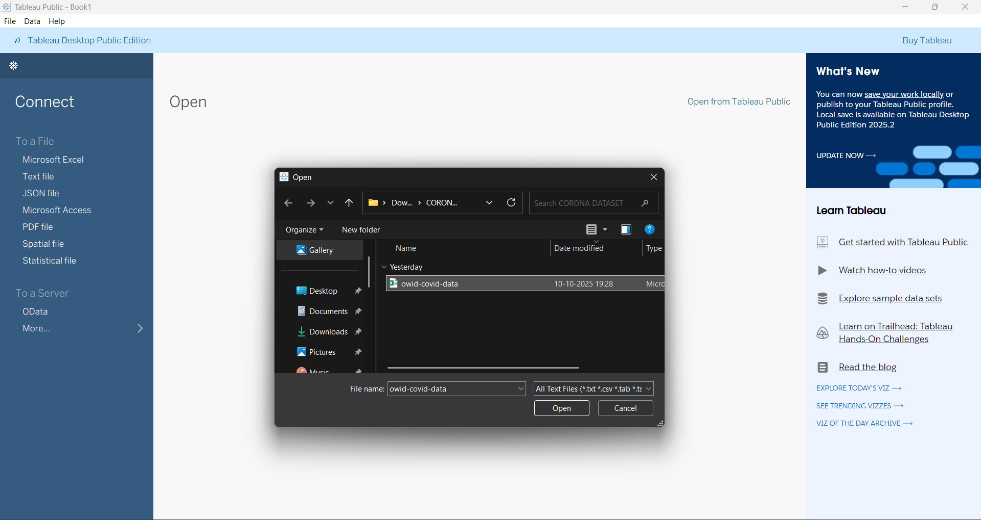

**Step 2: First Page after uploading, now click on sheet 1 to open the visualization page**

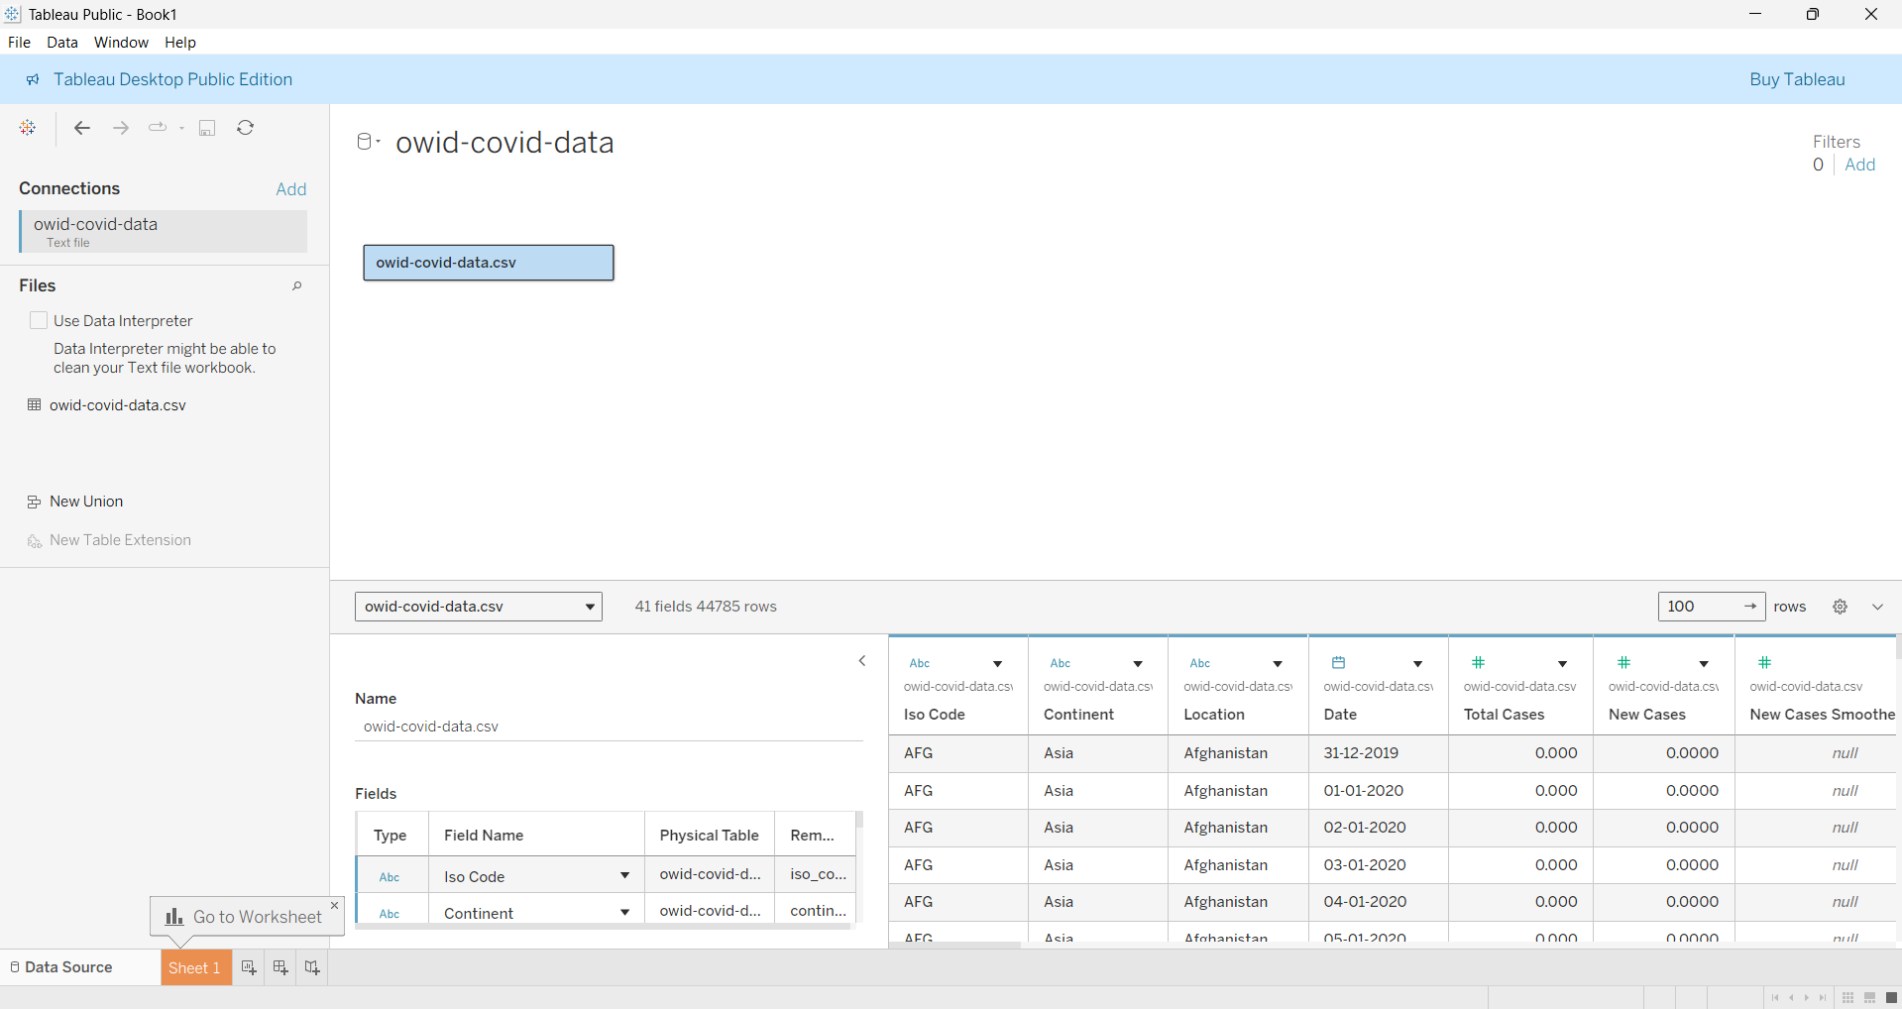

**Step 3: This is the Visualization Page**

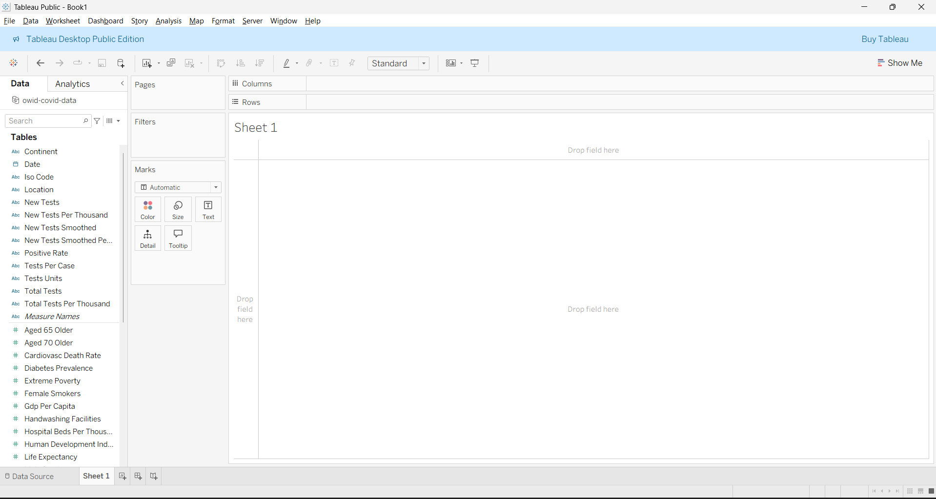

**Types Of Graphs :**

**1 . Bar Graph(Side-by-Side Graph) :**

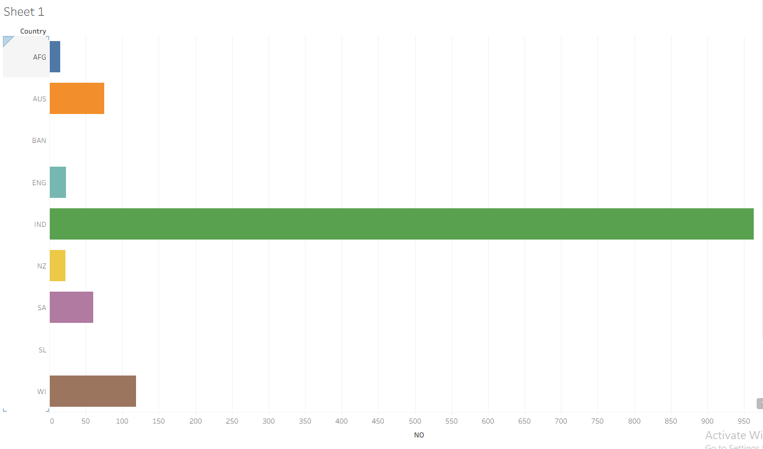

**2.HORIZONTAL BAR :**

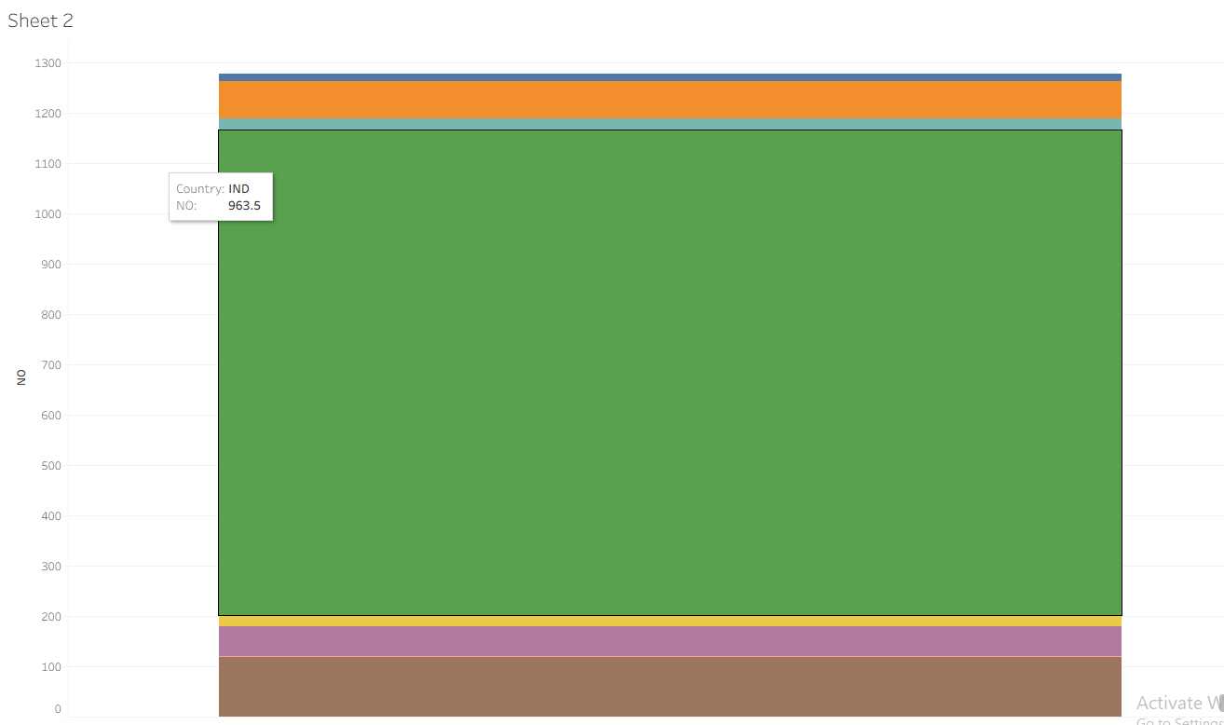

**3. SCATTER PLOT :**

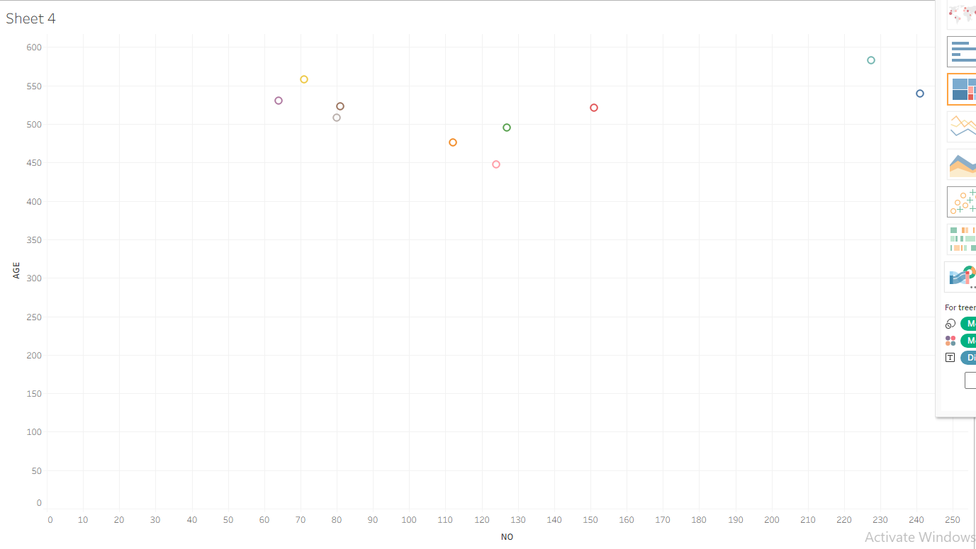

**4.BOX PLOT :**

